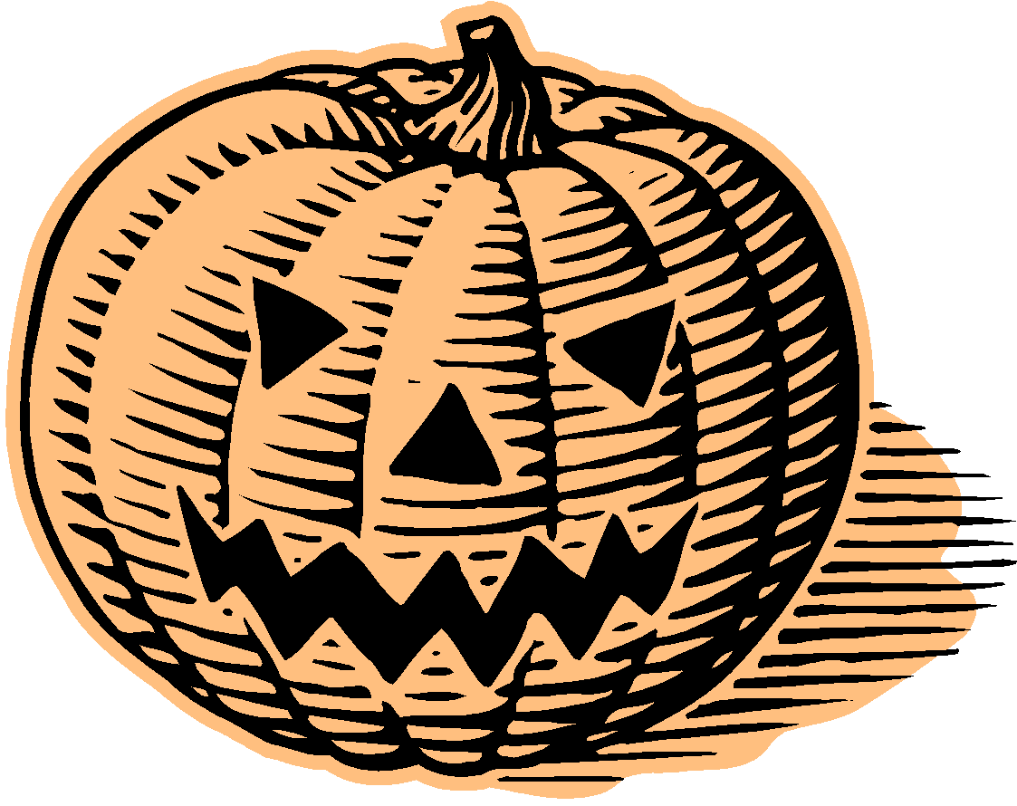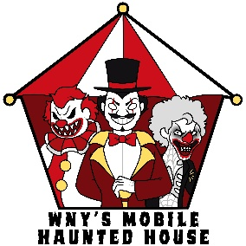
WNY’S MOBILE HAUNTED HOUSE

This year we have made our mobile haunted house bigger and better! We are currently looking for community sponsorships so that we can bring the excitement and joy to so many more!

You can help out by sponsoring us, and in doing so we will have a sign made showcasing your business that will be hung on the side of our mobile haunted house which will be seen by thousands.

We are 100% volunteer and don’t charge for any of the events we attend. We are able to bring so much joy and excitement to the communities solely based on donations from the public and generous sponsors like you.

Below are our sponsorship packages available and signing on with us will give you priority to have us for an event on a non-booked day. Your billboard/sign, with your company's name on it, will be on the side of our 29-foot trailer for all to see at all of our various events.

1 ft x 3 ft sign - $100.00

2 ft x 4 ft sign - $150.00

4 ft x 8 ft sign - $250.00

Should you have any questions or wish to become a sponsor please contact
Steve Krawczyk at (716) 597-7123, Brandon Kozlowski-Eleczko at (716) 548-9653, or Nick Szepetyk at (716) 574-2112.

You can also check us out on Facebook at WNY’s Mobile Haunted House.

Thank you in advance for your support!

WNY’S MOBILE HAUNTED HOUSE SPONSORSHIP FORM

1 ft x 3 ft sign - $100.00

2 ft x 4 ft sign - $150.00

4 ft x 8 ft sign - $250.00

Name of Sponsor: _____________________________________________

Sponsorship Level: ____________________________________________

Contact Name: ________________________________________________

Amount Enclosed: _____________________________________________

Address: _____________________________________________________

City: ______________________________ Zip Code: _________________

Please return filled out forms to the email below.
Thank you very much for your help in bringing continued joy to the community! Please email any PDF files, if one is preferred, to wnysmobilehaunt@gmail.com.

